NEW Engineers4Humanity website (Home Page & About US)

– Vin’s recommendations for improvement before Going Live
Home Page

Pages Pictures with Statements

Engineers4Humanity’s Mission
To build a dignified life for refugees and underserved communities in Rwanda, and promote country development by:
- Enhancing education & vocational skills development;
- Fostering self-reliance through job creation and entrepreneurship;
- Advancing engineering solutions for environmental protection, water, sanitation, and hygiene services; and
- Encouraging servant leadership and peacebuilding
Engineers4Humanity's Inspiration
Engineers4Humanity is a registered 501(c)(3) nonprofit organization based in Texas which guides and supports the Engineers4Humanity Consultancy social enterprise in Rwanda that fosters resilience and self-reliance in refugee camps through education, engineering, and servant leadership.

Founded by Eric Kamanzi — civil engineer, Project Management Professional, and former refugee — the organization has positively impacted more than 2,000 young refugees across Rwanda.
17+ Years of Impact
Since 2008, we have been transforming lives in Rwanda through scholarships, vocational training, public health engineering, and peacebuilding programs.

Our journey
Explore the milestones and moments that have shaped Engineers4Humanity. From our humble beginnings to transformative partnerships, each image tells a story of hope, resilience, and impact in refugee communities.

Picture of Hope School:

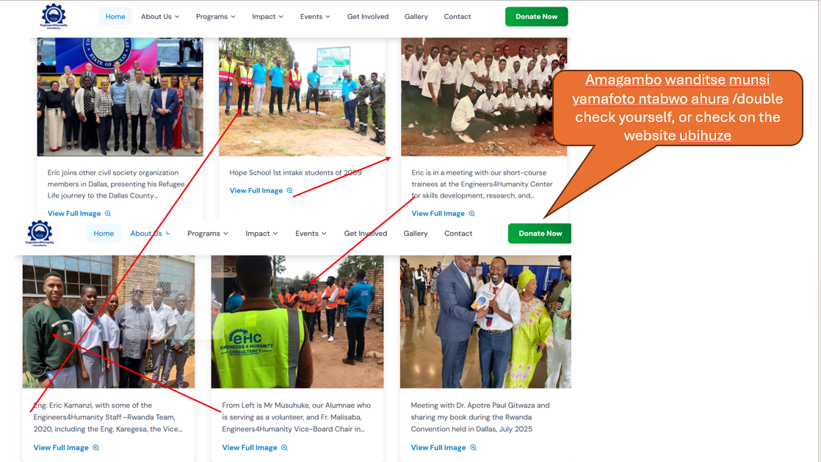

Hope School 1st intake students of 2009 with Theo Karegesa, Engineers4Humanity Board Vice Chair and Eric Kamanzi, Founder & CEO on the left in blue shirts.

Picture of Rwanda Team, 2020
Engineers4Humanity Rwanda Team, 2020, including Fr. Malisaba Straton,
Board Vice Chair for Education, and Rwanda Country Director, Eng.Fabrice Kayisire.

Peacebuilding
Encouraging servant leadership and peacebuilding initiatives in Rwanda for lasting impact.

Public Health Engineering Initiatives
Addressing Water, Sanitation, and Hygiene (WASH) challenges in Rwanda refugee camps through sustainable engineering systems.

Social Entrepreneurship & Construction Service
A registered social enterprise, Engineers4Humanity Consultancy Ltd providing engineering and environmental consultancy services, creating jobs and supporting sustainable development in Rwanda through construction service

Our Programs

Adjust on the Education instead of writing vocation skills development Vocational Training to avoid confuse with the Engineers4Humanity Institute (will be independent School later)
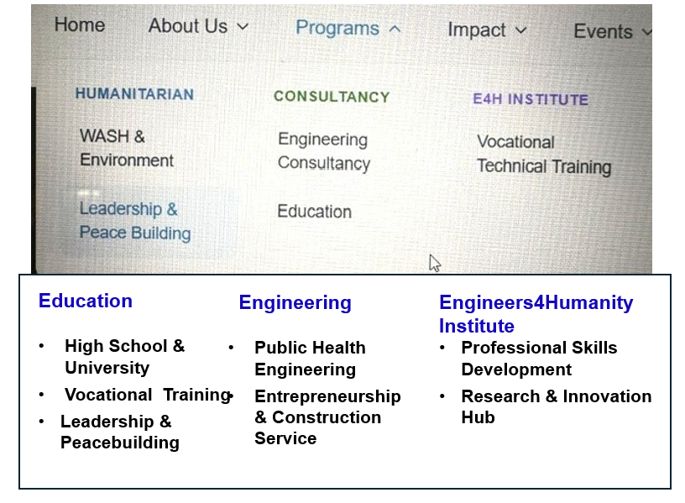

For the Bottom section .

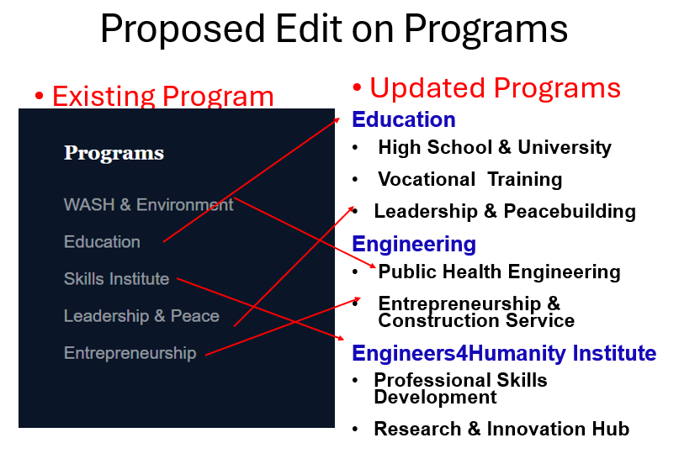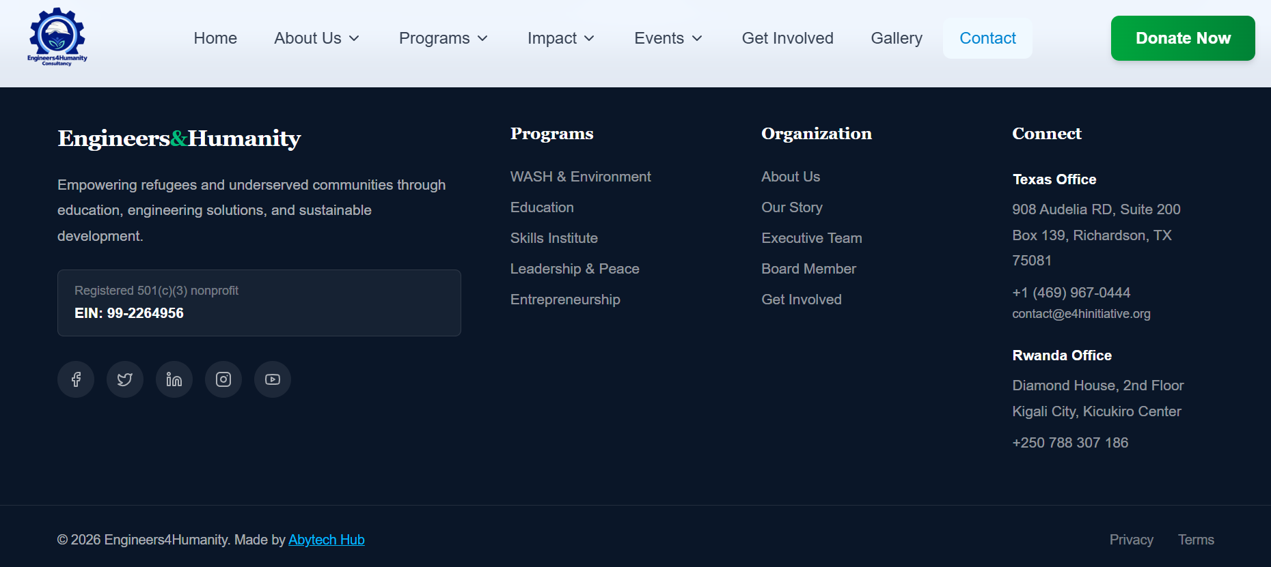
If possible, you can change this black background, or you can use other logo with different background, I will share with you too.

Using a black background

Your Support Makes a Difference (all okay)
Whether through donations, volunteering, or spreading the word, you can help empower vulnerable communities and create lasting change.
Make a Donation

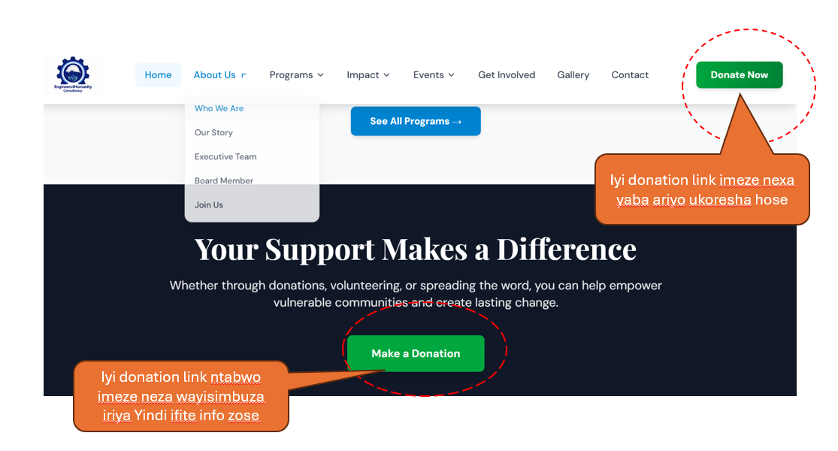

The “See All Programs” should link to the “Programs” menu item at the top of the Home Page.

Who We Are
About us
Founded by philanthropist Eric Kamanzi, Engineers4Humanity is a refugee-founded nonprofit organization with a U.S. 501(c)(3) organization registration in Dallas, Texas, in 2024 with the EIN: 99-2264956
It was inspired by Eric's experience as a refugee and founder of the Engineers4Humanity Consultancy, a social enterprise with TIN#111054632 operating in Rwandasince 2020.
For more than 2 decades, after witnessing firsthand the struggles of refugees and displaced communities, mainly challenges in public health engineering, youth unemployment, education, and limited vocational pathways,

In response to these persistent challenges, Engineer Eric was determined to develop a sustainable Engineering solution to foster long-term resilience and self-reliance among refugees and to play a key role in sustainable peacebuilding in the region by Establishing a social Enterprise Engineers4Humanity consultancy in Rwanda 2020.

In 2024, as an immigrant, Eric pursued his humanitarian mission by establishing the nonprofit Engineers4Humanity in the USA, a 501 (c) (3) to guide and support its social enterprise in Rwanda.

Since then, Engineers4Humanity has been transforming lives across Rwanda. Through education scholarships, vocational training, environmental stewardship, and peace-building programs, the organization empowers refugees and underserved communities to build self-reliant, dignified, and resilient futures.

For more about us, check out our story, our founder's book “Breaking Boundaries”, and Hope School Alumnae's Testimony at the link below.

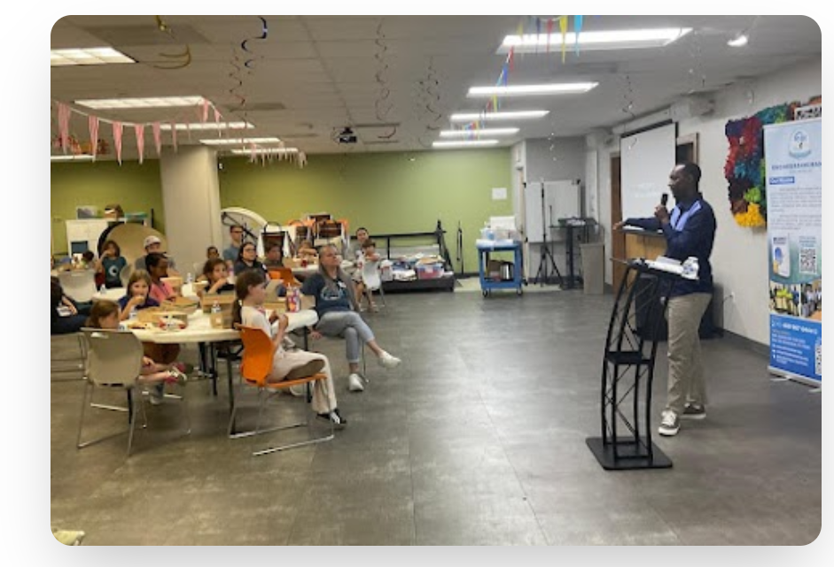

Organization Vision

“We envision a brighter future for all, where refugees and underserved communities thrive through empowerment, advocacy, and sustainable engineering solutions.”

Organization Mission

To build a dignified life for refugees and underserved communities in Rwanda, and promote country development by:
- Enhancing education & vocational skills development;
- Fostering self-reliance through job creation and entrepreneurship;
- Advancing engineering solutions for environmental protection, water, sanitation, and hygiene services; and
- Inspiring servant leadership and elevating youth and women’s participation to drive sustainable peacebuilding initiatives in the region.
Eric's humanitarian journey began in 2008, when he gathered other young refugee students to explore how they could find lasting solutions to their daily challenges.
They founded the youth club- Forum Amis de la Paix, Eric served as the organization's first president and later as board chair. One notable achievement of the Forum is the establishment of Hope School in 2009, a refugee initiative school in the Gihembe refugee camp. Nonprofit organizations, including UNHCR, stopped offering free high school education programs, due to a funding shortage.
Eric, along with his refugee friends, founded the Hope School that offered education grades from grade 10 to 12 More than 500 students graduated from the school, including more than 400 students from high school. Their lives and opportunities have remarkably improved. After graduating from the University of Rwanda as a civil engineer, Eric found that engineering could fulfill his mission. In 2020 in Rwanda, he launched the Engineers4Humanity Consultantcy, a social enterprise that provides public health engineering, STEM education, and vocational training services for young refugees.
As an immigrant, in 2024, Eric pursued his humanitarian mission by establishing the nonprofit Engineers4Humanity in the U.S. to guide and support its social enterprise in Rwanda,

For more about our story, check out our founder's book, Breaking Boundaries, and Hope School Alumnae's Testimony at the link below.

Values & Culture
Engineers4Humanity’s RUSINE Principles Value
Our Identity
Our organization is built on a simple conviction: every person carries dignity, potential, and the capacity to transform their own future when given opportunity, support, and community.
Engineers4Humnaity’sRUSINE Principles—Resilience, Ubuntu, Self-Reliance, Integrity, Non-Violence, and Excellence—anchor who we are, how we lead, and how we serve. These values guide our decisions, shape our partnerships, and define the culture we cultivate across teams, communities, and countries.

(No change need on Values well written, change only this introduction)

Our Story

Founder’s personal story, calling, & establishment of Engineers4Humanity

Eric KAMANZI, PE, PMP
Founder & CEO, Engineers4Humanity

Eric Kamanzi & Engineers4Humanity
A God-Given Calling Shaped by Faith, Tragedy, Purpose, and Impact
Eric Kamanzi’s life and work are rooted in a profound journey of survival, faith, and a deep commitment to restoring dignity for refugee youth. Born in 1986 in the Democratic Republic of Congo and raised as the eldest of five, his childhood was marked by responsibility and leadership. At age 10, he fled with his family to Rwanda, and one year later survived the 1997 Mudende Massacre, where his father was killed while protecting him and his siblings. This tragedy became the defining moment that shaped his lifelong mission.
Growing up in the Gihembe Refugee Camp for 25 years, Eric developed a philosophy rooted in self-reliance, education, and God’s promises. His father’s wisdom and principle “Teach a man to fish and you feed him for a lifetime”—shaped his understanding of responsibility and dignity. Eric expanded this into his own conviction: “If you teach a child, you give him a lifetime gift.” These principles became the foundation of Engineers4Humanity.
His purpose was strengthened by Nelson Mandela’s belief in the power of education and by the Scriptures that shaped his identity. He held tightly to God’s assurance: “Before I formed you in the womb I knew you, before you were born I set you apart.” — Jeremiah 1:5 and to God’s promise of hope: “For I know the plans I have for you… plans to give you hope and a future.” — Jeremiah 29:11
Eric’s calling was shaped not only by tragedy and resilience, but by a deep family devotion to faith. Anchored in the declaration, “As for me and my house, we will serve the Lord.” — Joshua 24:15, his family held firmly to God’s promises through years of hardship. Their restoration—now reunited and living together in Dallas, Texas—is a living testimony of God’s faithfulness.
This same faith fuels Eric’s lifelong commitment to serve and advocate for refugee families who remain in camps today—families still facing the same misery, uncertainty, and daily struggle he once lived through. He carries their stories in his heart, and every initiative he leads is driven by the conviction that no child should grow up without opportunity, and no family should remain trapped in hopelessness.
Today, as a father of four, Eric is intentional about raising his children with the same values of faith, service, and purpose that shaped his own life—and with a deep awareness of the responsibility to uplift those still waiting for the chance he was given.

His humanitarian mission emerged early:
- 2004: Served more than 70 orphaned students through the Survivors’ Association named AERG at High school.
- 2007: Met Pastor Rick Warren in Kigali and read The Purpose Driven Life, a moment that spiritually confirmed his God-given calling.
- 2008: Co-founded the Refugee Youth Club – Forum Amis de la Paix, advancing education, peacebuilding, and youth empowerment.
- 2009: Helped establish Hope School, a refugee-led secondary school that became a lifeline for hundreds of students.
In 2013, Eric launched a small vocational training pilot for 10 unemployed refugee graduates—an initiative that transformed lives and became the seed of Engineers4Humanity. In 2014, meet with former Byimana School principal, Frère Malisaba who helped expand this vision and open doors for hundreds of refugee youth in vocational training and high school.
Even after Hope School closed in 2016, Eric continued building solutions to address the ongoing challenges facing Rwanda’s 135,000+ refugees—unemployment, lack of skills, limited education access, environmental pressures, and persistent poverty.
As a Civil Engineer, he transformed engineering into a mission of restoration, building hope and self-reliance:
- Engineers4Humanity Consultancy (2020)
- Center for Innovation & Vocational Skills Development (2021)
- Engineers4Humanity 501(c)(3) in Texas (2024)
Today, Eric is a global advocate, author of Breaking Boundaries, and a leader in refugee empowerment with 17+ years of measurable impact, where more than 2000 youth change lives through education and mentorship.
Engineers4Humanity stands as a faith-rooted movement born from tragedy and transformed into purpose—committed to building a world where every refugee child can learn, work, and live with dignity.

Meet Engineers4Humanity's Education Program Champion
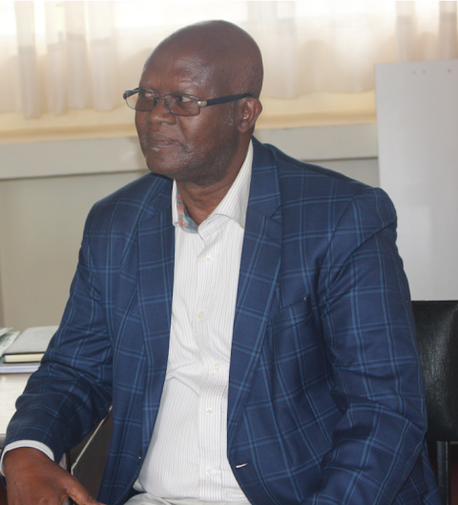
Mr. Frere Malisaba Straton
Frère Malisaba Straton is a Catholic Marist Brother, an accomplished educator, and a humanitarian leader whose five decades of service have strengthened schools and communities across East Africa. A former Deputy Provincial Superior of the Marist Brothers and a trained human-rights educator, he has championed child protection, academic excellence, and the dignity of vulnerable learners throughout his career.
We are profoundly grateful for his compassion and leadership, which have shaped refugee education for more than twenty years and continues to guide Engineers4Humanity today. After visiting Hope School in 2013 at the request of his friend Mrs. Lycie, he saw firsthand the challenges refugee students faced and immediately began advocating for mobilizing support, writing to partners, and contributing his own resources. His 2014 meeting with Eric in Kigali deepened their shared commitment to vocational training and youth empowerment.
Through partnerships with Rwabuye Vocational Center, and Engineers4humanity, launched short-course training programs, from 2015 enabling more than 200 refugee youth to gain practical skills and access scholarships from centers including Latoye in Kigali. After Hope School closed, Frère Malisaba continued working closely with Eric and played a key role in establishing Engineers4Humanity, where he now serves as Board Vice Chair for Education Programs.
His mentorship, advocacy, and unwavering belief in refugee youth have transformed countless lives. He remains a cornerstone of Engineers4Humanity’s mission—and a guiding force who has shaped Eric’s vision from the beginning until today.

Remove Forum Story and Adjust this as Forum and Hope school story

Hope school success story and Inspiration of Engineers4Humanity

Engineers4Humanity was born from inspiration of Hope School, a journey of resilience, faith, and the belief that refugee youth can rise when given opportunity. Our founder, Eric, spent 25 years in the Gihembe Refugee Camp, where he learned that education, skills, and hope are the most powerful tools a young person can have.
Where It Began: Forum Amis de la Paix (2008)
In 2008, Eric co-founded the Refugee Youth Club – Forum Amis de la Paix, the first youth-led movement in the camp. The Forum united young people around education, peacebuilding, and community service. But one challenge became impossible to ignore:
Refugee students had no access to secondary education.
This realization sparked a bold idea that changed the future of the camp.
Hope School: A Seed of Hope (2009–2016)
With no classrooms, no funding, and no infrastructure, Forum leaders launched what would become Hope School. On January 19, 2009, Inkurunziza Church opened its doors to the first students. To encourage them, Eric wrote a message on the cover of the three teacher syllabus books—History, Geography, and Economics—books he had received from Riviera High School in Kigali:
“Never give up, never lose hope. In God we trust.”
A student named Shyengo was inspired to give the school its name—Hope School.
The school grew through sacrifice and unity. Teachers volunteered for a full year without pay. The community built classrooms from plastic sheeting, mud walls, and timber. Families contributed 70 RWF (about $0.12) to keep the school alive.
Despite these conditions, Hope School became the top-performing school in the district. Every student passed the national exam, and one earned a perfect 100%. Over seven years, more than 500 students graduated—many now leaders in Rwanda, the USA, Canada, and Europe, and many serving today as Engineers4Humanity volunteers.
Hope School closed in 2016 due to infrastructure and financial challenges, but its legacy lives on.
A New Challenge: Skills and Employment (2013)
Even before the school closed, Eric saw the next barrier: graduates had no jobs, no practical skills, no access to college or university education, and no opportunities.
In 2013, he launched an on-the-job training pilot for 10 Hope School graduates. They learned masonry, steel fixing, carpentry, and construction directly on worksites. Within months, they were earning income and supporting their families.
This pilot became the first spark of Engineers4Humanity.
Partners Who Carried the Mission
Our journey has been strengthened by partners who believe in refugee potential, including:
- Impact Hope (Mindy Thygeson)
- ADRA
- World Vision
- These Numbers Have Faces
- Many churches, schools, and community leaders
Their support has opened doors for thousands of refugee youth.

Gratitude to Those Who Carried the Mission
Eric is deeply grateful to Forum Members, school Principal Mr. Baudouin Ntabareshya, Nsengiyera Jean former refugee leaders who are both resettled in the USA, the dedicated teachers, staff, churches, youth volunteers, and the partner schools who supported Hope School with scholarships and supplies.
He honors the students who trusted the mission and worked hard to succeed, and the entire Gihembe refugee community, whose voluntary contribution of 70 RWF (about $0.12) made secondary education possible for more than 500 students. Their unity and sacrifice helped shape leaders now serving globally and many who continue giving back through Engineers4Humanity. Their journey proves that hope, once planted, grows across generations and continents.

Engineers4Humanity Today
Engineers4Humanity is the natural evolution of this story:
- Forum awakened youth leadership.
- Hope School opened access to education.
- The 2013 pilot proved that skills create dignity and income.
Today, Engineers4Humanity equips refugee youth with engineering skills, vocational training, innovation, and pathways to employment—building sustainable solutions for families who still face the hardships Eric once lived through.
The seed of hope planted in 2009 continues to grow—transforming lives, communities, and futures.

Our Team (since Executive means senior management change to “Our Team”

Board of Directors

Vin Hoey, Board Chair

Vin Hoey serves as the Engineers4Humanity Board Chair. A senior executive with extensive business and nonprofit leadership experience, he is passionate about serving nonprofits and teaching/mentoring the next generation of leaders. He brings nonprofit board and senior staff experience perspectives to fuel success for causes.

He is Managing Director of Strategic4sight, which provides leading-edge nonprofit strategic planning, marketing, leadership coaching, and governance consulting services. Throughout his career, Vin has provided significant volunteer leadership on the boards of directors of 25 different local, national, and international nonprofit organizations in various cities. He has served as board chair for 10 nonprofits and co-founded four nonprofits. He is committed to serving refugees and vulnerable youth and currently serves on the Leadership Advisory Councils of Heart House and Project Transformation - North Texas in Dallas.

Vin’s servant leadership aligns directly with Engineers4Humanity's mission to restore dignity, expand opportunity, and build pathways to self-reliance for displaced and underserved communities. He supports Engineers4Humanity's ability to build partnerships and mobilize resources for refugee self-reliance, job creation, and vocational training programs in Rwanda.

His long career at ExxonMobil included serving as Global Marketing Communications Manager for ExxonMobil Chemical and earlier leading Corporate & Marketing Communications across Europe, Africa, and the Middle East from Brussels. He found, late in life, that he loves teaching and has taught the Nonprofit Marketing Strategies course at the SMU Cox Graduate School of Business in Dallas, and undergraduate courses at SMU and DePauw University in Indiana.

As Board Chair of Engineers4Humanity, Vin plays a pivotal role in developing strategic partnerships, donor engagement, and helping programs across Rwanda. His leadership strengthens board governance and supports the organization's mission.

Eric Kamanzi, Founder & Chief Executive Officer
Role & Impact

Eric Kamanzi is the Founder & CEO of Engineers4Humanity—a civil engineer, humanitarian leader, and a father, whose journey from surviving violence in the DRC to growing up in a refugee camp in Rwanda has shaped a lifelong mission to restore dignity, hope, and opportunity for displaced communities. His story is captured in his book “Breaking Boundaries”available at Amazon, which chronicles his path from hardship to purpose-driven leadership.
Eric’s values were formed by his father, a courageous social entrepreneur who taught self-reliance, generosity, and service. During the 1997 Mudende Refugee Camp massacre, his father sacrificed his life to save Eric and his siblings—an event that became the defining anchor of Eric’s faith and calling. Guided by Scripture, by meeting Pastor Rick Warren in 2007, and by global human-rights advocates, Eric embraced a life of impact rooted in the declaration: “As for me and my house, we will serve the Lord.” His purpose remains clear: to live a happy and impactful life.
For 17 years, Eric has led transformative initiatives for refugees in Rwanda, co-founding Forum Amis de la Paix (2008) and establishing Hope School (2009), which enabled more than 500 high school graduates and 100 university students. In 2020, he launched Engineers4Humanity Consultancy and the Engineers4Humanity Technical & Innovation Hub, advancing vocational training, climate-smart engineering, WASH solutions, and youth employment.
A Civil Engineer and PMP-certified professional, Eric has led more than 100 construction projects and serves as a Special Inspector at DFW International Airport. He is an active member of NSPE, PMI, Engineers Without Borders–USA, UNA-USA, the Institute of Engineers Rwanda, and RAPEP. Through Engineers4Humanity, he has impacted thousands of refugees and more than 2,000 youth—championing dignity, self-reliance, and community-driven development.

Malisaba Straton Board Vice Chair for Education Programs
Role & Impact
Brother Malisaba Straton is a Marist brother, experienced educator and humanitarian leader whose five decades of service have strengthened schools and communities across East Africa (Rwanda, the DRC, Tanzania and Kenya) and with global network in education in the USA and Europe. As Engineers4Humanity Board Vice Chair for Education , he guides the organization's strategy for refugee education, school partnerships, and youth empowerment.
Brother Straton has led and transformed numerous institutions, including Byimana School of Science—where he introduced Rwanda's first wireless internet in a public school—and Rwabuye Technical School, which he revitalized from 90 to 300 students within three years. His leadership has consistently combined academic excellence, financial discipline, and a deep commitment to student well-being.
He served as Deputy Provincial Superior of the Marist Brothers in Central and East Africa, supervised major school infrastructure projects, and held governance roles in national companies. A trained human rights educator, he has participated in international workshops in Geneva and has been a strong advocate for child protection and refugee learners.
Through a partnership with Engineers4Humanity, Brother Straton has helped refugee students access quality boarding schools, vocational training, mentorship, and long-term academic support. His lifelong dedication to education and human dignity continues to shape the next generation of leaders across East and Central Africa.

Theo Karegesa Kivuye, MEng
Board Vice Chair for Engineering Programs

Role & Impact
Karegesa Muyango is an engineering leader, entrepreneur, and former refugee whose lived experience fuels his commitment to building pathways of dignity and opportunity for displaced youth. As Managing Director of VBN General Ventures Ltd in Kigali and Engineers4Humanity’s Board Vice Chair for Engineering Programs, he provides strategic leadership across WASH, environmental protection, infrastructure development, and workforce-creation initiatives that equip refugee engineers to thrive.
With a BSc in Chemistry and Mechanical Engineering training from the American University in Cairo, Karegesa brings more than three decades of technical and managerial experience. His engineering portfolio spans logistics, mining, hydropower subcontracting, industrial installations, wastewater and effluent management, dumpsite stabilization, and large-scale environmental restoration—alongside landmark landscaping projects such as Epic Hotel and Kivu Marina Bay Hotel.
A champion of refugee-to-leader transformation, he mentors young engineers, supports internship and job placement through Engineers4Humanity, and advocates for STEM as a tool for equitable development. His humanitarian service includes rehabilitation support for war-injured veterans, facilitating artificial limb procurement, and training Rwanda National Police after specialized fire-engine instruction in Japan.
As a founder and director of multiple companies—including SAMBAMBA Freight Forwarders, Two-K Enterprises, and VBN General Ventures—he has played a pivotal role in Rwanda’s post-genocide reconstruction, from linking the country to Mombasa Port to advancing housing, energy, and industrial development.
Karegesa embodies engineering leadership rooted in resilience, service, and community-centered innovation—demonstrating the capacity to guide transformative engineering programs that advance dignity, self-reliance, and sustainable peace.

Japhet Habinshuti
PEng, MSc
Board Member

Role & Impact
Japhet is a leading Urban Planning and Climate Resilience expert with more than 13 years of experience delivering high-impact, community-centered solutions across Sub-Saharan Africa. He has mobilized tens of millions of dollars in climate adaptation, gender equity, and urban resilience investments—directly improving the lives of informal settlement residents, women, youth, and climate-exposed households.
He currently serves in Rwanda with the World Resources Institute (WRI) as a key implementer of the Africa Climate Resilient Cities Program, where he leads the US $22 million SUNCASA initiative, reducing flood risk for over 2 million people across Rwanda, Ethiopia, and South Africa. His leadership has shaped Kigali’s first Urban Resilience Roadmap, secured major climate-finance commitments through the World Bank’s Gap Fund, and advanced gender-responsive mobility, digital inclusion, and post-COVID recovery programs.
Japhet’s career includes influential roles with the World Bank, the Global Covenant of Mayors, the Resilient Cities Network, UNESCO, and Rwanda’s Natural Resources Authority. Across these institutions, he has built a reputation for turning policy into practice—strengthening local government capacity and designing nature-based, GESI-responsive solutions that deliver measurable and scalable impact.
As an Engineers4Humanity Board Member, Japhet brings strategic leadership in climate adaptation, urban resilience, inclusive planning, and climate-finance mobilization. His expertise directly strengthens the organization’s mission to equip refugees and host communities with engineering skills, resilient infrastructure, and dignified economic opportunities—ensuring they can thrive amid growing climate and economic shocks.

Joseph Masengesho, MBA
Board Member
Role & Impact

Joseph Masengesho is an experienced project management professional with an MBA and 14 years of experience advancing youth employment, entrepreneurship, and vocational skills development across Rwanda. His work with leading international development agencies—including AFD/Expertise France, APEFE, and DOT Rwanda—has focused on empowering vulnerable youth, women, and people with disabilities through TVET training, dual apprenticeship systems, and private-sector–driven job creation.

Joseph has coordinated multi-stakeholder programs that strengthen TVET–industry collaboration, build the capacity of trainers and SMEs, and expand access to skills training and workplace integration for disadvantaged groups. He has led teams, managed project resources, and delivered large-scale training initiatives that have equipped thousands of young people with practical skills for employment and entrepreneurship.

Currently serving in Rwanda as Manager for Entrepreneurship, Employment, and Private Sector Engagement under the AFD/Expertise France AFTER I & II Projects, Joseph oversees the design and implementation of workforce development interventions, employer engagement strategies, and capacity-building programs for national TVET institutions.

As an Engineers4Humanity,Board Member of Joseph brings deep expertise in vocational training systems, youth workforce development, and inclusive job creation. His leadership strengthens Engineers4Humanity's mission to equip refugees and host communities with market-relevant skills, expand pathways to dignified employment, and build resilient livelihoods through engineering and technical education.

J. Baptist Ndahiriwe
MPH
Board Member
Role & Impact
Ndahiriwe is a senior health systems consultant with over 20 years of experience across clinical practice, academia, regulation, and health policy in Rwanda and the East African region. He has led major national and regional initiatives focused on strengthening health workforce standards, accreditation systems, institutional governance, and quality assurance expertise that directly support Engineers4Humanity's Public Health Engineering mission.

With deep experience in developing scopes of practice, training standards, accreditation frameworks, and compliance audits, he brings a strong foundation for improving the quality and safety of community-level health and WASH services. His leadership in curriculum development, education harmonization, and higher education quality assurance aligns with Engineers4Humanity's commitment to delivering high-quality vocational training and expanding job-creation pathways for refugee and host communities.

Ndahiriwe has served on high-level Ministry of Health technical committees, regulatory councils, and university governance structures, and has contributed to major health systems strengthening projects, including serving as Technical Lead for the HSS NEXT project. He currently consults with Building Systems for Health on a Gates Foundation–funded Primary Health Care Performance Management initiative in Rwanda and Ghana.

He holds bachelor's degrees in Diagnostic Imaging and Pharmaceutical Sciences, a master's degree in medical Imaging, and a Master of Public Health in Global Health. Fluent in English and French, he brings strong strategic, analytical, and governance expertise to the Board of Engineers4Humanity.

Boxes at bottom

Partner With Us (I recommend deleting this box, unless you can focus it on serving Rwanda.)
Are you an organization or company looking to make an impact? We're seeking qualified and competent personnel from refugees and host community, self-reliance program and never leave any one behind program. We welcome partnerships with businesses, research centers, peace-building institutions, youth organizations, universities, high schools, academic institutions, and humanitarian organizations. Together we can create lasting change.

